Case Study 05: Water Tank Inflow-Outflow & Level Monitoring System

1. Problem Statement

Develop a Python program to track and monitor the water volume inside a storage reservoir over a 3-day observation window. The system starts with an initial baseline quantity and observes daily inflow and outflow volumes. It must enforce upper bounds (maximum storage capacity) and lower bounds (minimum capacity threshold of zero litres), trigger automated warnings when overflow or shortage situations occur, compute end-of-day balances, and pinpoint the exact day on which a designated capacity target is first reached.

2. Objectives

- To simulate state-based fluid balance dynamics using fixed-iteration for loops across multiple discrete intervals.

- To implement conditional clamping to maintain reservoir water levels strictly within physical limits ($\left[0,\text{capacity}\right]$).

- To detect and announce system anomalies such as tank overflow and critical shortage states.

- To record the earliest day a threshold target is reached using sentinel flag/latching logic (None state tracking).

3. Assumptions

- The system begins with an initial water level of 40 litres, a maximum tank capacity of 100 litres, and a tracking target threshold of 80 litres.

- Daily inflow and outflow measurements are entered as integer quantities.

- If net water level exceeds capacity (100 litres), excess fluid is lost to overflow and the level is capped at 100 litres.

- If net water level falls below zero, fluid cannot be negative; a shortage is reported and the balance is clamped to 0 litres.

- The target achievement day is locked when first met during the 3-day cycle and is not overwritten by subsequent fluctuations.

4. Algorithm

- Step 1: Start the program.

- Step 2: Initialize simulation constants and state variables: level = 40, capacity = 100, target = 80, and target_day = None.

- Step 3: For each day in range(1, 4) (Day 1 through Day 3):

  - Prompt and read integer inputs for inflow and outflow.

  - Update current reservoir volume: level = level + inflow - outflow.

  - If level > capacity: print "Overflow detected" and clamp level = capacity.

  - If level < 0: print "Shortage detected" and clamp level = 0.

  - Display the updated end-of-day level: "Water level: <level> litres".

  - If level >= target and target_day is None: assign target_day = day.

- Step 4: After completing the 3-day loop:

  - If target_day is None, print "Target was not reached".

  - Otherwise, print "Target first reached on day <target_day>".

- Step 5: Stop the program.

5. Flowchart Logic / Diagram

Plaintext
[Start]
│
▼
[Initialize variables:
level = 40, cap = 100,
target = 80, target_day = None]
│
▼
<For day = 1 to 3> ──────────────────────────────┐
│ │
▼ │
[Input inflow, outflow] │
[level = level + inflow - outflow] │
│ │
▼ │
<level > 100?> ──(Yes)──> [Print "Overflow", │
│ level = 100] │
(No) │ │
▼ │ │
<level < 0?> ──(Yes)──> [Print "Shortage", │
│ level = 0] │
(No) │ │
▼ │ │
[Print current level] <───────────┘ │
│ │
▼ │
<level >= target and target_day is None?> │
│ │ │
(Yes)│ (No)│ │
▼ │ │
[target_day = day] │ │
│ │ │
└──────────────┬───────┘ │
│ │
└─────────────────────────────┘
│ (loop completed)
▼
<target_day is None?>
│ │
(Yes)│ │(No)
▼ ▼
[Print "Target was [Print "Target first
not reached"] reached on day X"]
│ │
└───────┬──────┘
▼
[End]

6. Pseudocode

Plaintext
BEGIN
SET level = 40
SET capacity = 100
SET target = 80
SET target_day = NULL

FOR day FROM 1 TO 3 DO
PRINT "Day " + day + " inflow (litres): "
READ inflow
PRINT "Day " + day + " outflow (litres): "
READ outflow

level = level + inflow - outflow

IF level > capacity THEN
PRINT "Overflow detected"
level = capacity
END IF

IF level < 0 THEN
PRINT "Shortage detected"
level = 0
END IF

PRINT "Water level:", level, "litres"

IF level >= target AND target_day IS NULL THEN
target_day = day
END IF
END FOR

IF target_day IS NULL THEN
PRINT "Target was not reached"
ELSE
PRINT "Target first reached on day", target_day
END IF
END

7. Python Source Code

Python
# Water Tank Inflow-Outflow & Level Monitoring System

# System baseline specifications
level = 40
capacity = 100
target = 80
target_day = None

# Simulate tank operations over 3 days
for day in range(1, 4):
inflow = int(input("Day " + str(day) + " inflow (litres): "))
outflow = int(input("Day " + str(day) + " outflow (litres): "))
level = level + inflow - outflow

# Boundary enforcement for overflow
if level > capacity:
print("Overflow detected")
level = capacity

# Boundary enforcement for shortage
if level < 0:
print("Shortage detected")
level = 0

print("Water level:", level, "litres")

# Latch target achievement day
if level >= target and target_day is None:
target_day = day

# Final status evaluation
if target_day is None:
print("Target was not reached")
else:
print("Target first reached on day", target_day)

8. Test Cases

Test Case ID | Input Sequence (Inflow, Outflow) | Expected Output | Actual Output | Status
TC_01 (Target Reached Day 2) | Day 1: 30, 10  Day 2: 30, 5  Day 3: 10, 20 | Day 1: Level 60  Day 2: Level 85  Day 3: Level 75  Target first reached on day 2 | Water level: 60 litres  Water level: 85 litres  Water level: 75 litres  Target first reached on day 2 | Pass
TC_02 (Overflow on Day 1) | Day 1: 80, 10  Day 2: 10, 20  Day 3: 5, 15 | Day 1: Overflow detected, Level 100  Day 2: Level 90  Day 3: Level 80  Target first reached on day 1 | Overflow detected  Water level: 100 litres  Water level: 90 litres  Water level: 80 litres  Target first reached on day 1 | Pass
TC_03 (Shortage on Day 1 & Target Not Reached) | Day 1: 10, 60  Day 2: 20, 10  Day 3: 15, 5 | Day 1: Shortage detected, Level 0  Day 2: Level 10  Day 3: Level 20  Target was not reached | Shortage detected  Water level: 0 litres  Water level: 10 litres  Water level: 20 litres  Target was not reached | Pass
TC_04 (Flips Above Target Multiple Days) | Day 1: 50, 10  Day 2: 10, 5  Day 3: 15, 10 | Day 1: Level 80  Day 2: Level 85  Day 3: Level 90  Target first reached on day 1 | Water level: 80 litres  Water level: 85 litres  Water level: 90 litres  Target first reached on day 1 | Pass

9. Output Screenshots

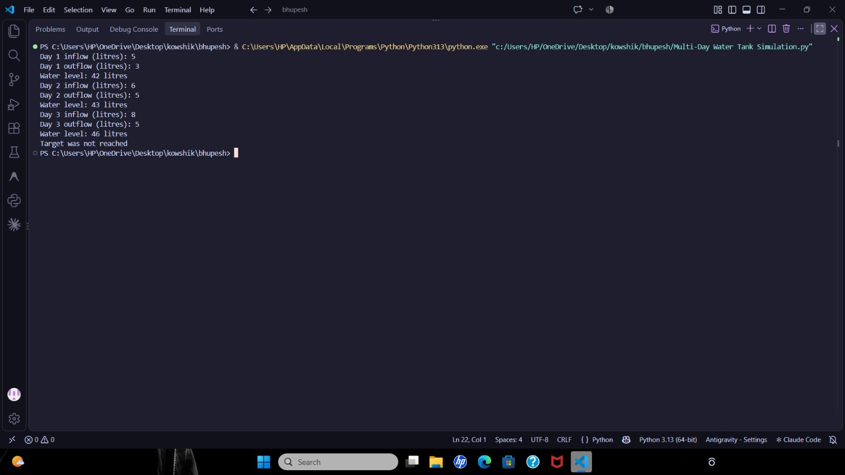

10. Conclusion

The Water Tank Inflow-Outflow & Level Monitoring System was executed and verified successfully. The script demonstrates iterative boundary clamping, conditional state updates, threshold latching logic using Python's None sentinel type, and multi-day status tracking.

